Rachel Boate

Abstraction-Création

Abstraction-Création began in 1931 as a broad collective of Abstract artists active in Paris until 1936. Theo Van Doesburg, Jean Arp, Albert Gleizes, Jean Hélion, Auguste Herbin, František Kupka, Léon Arthur Tutundjian, Georges Valmier, and Georges Vantongerloo composed the founding committee. Participating artists were represented through the publication of an annual journal, *Abstraction, Création, Art Non-Figuratif* that ran from 1932 to 1936. This *cahier* featured reproductions of abstract paintings, sculpture, and photography, alongside individual artists’ statements. The group primarily aimed to promote an international network of abstract artists and simultaneously form an aesthetic counterpoint against the increasing prevalence of Surrealism and Social Realism in France. Following the failure of the narrowly conceived Abstract groups—Art Concret and Cercle et Carré of 1930—Abstraction-Création named non-figuration the only criterion for membership. Such a pluralist conception of abstraction reflected an intentionally democratic cultural position in contrast to the totalitarian regimes emerging elsewhere in Europe throughout the 1930s. At its peak, contributing members to the group included well-known abstractionists as diverse as Piet Mondrian, Vasily Kandinsky, Lázló Moholy-Nagy, Kurt Schwitters, Jacques Villon, Willi Baumeister, and Alexander Calder. Furthermore, a year long exhibition of Abstraction-Création artworks began in December 1933 on the ground floor of 44 Avenue de Wagram, Paris. The 1935 magazine issue claimed a membership of over 400 individuals that hailed from seventeen countries outside of France.

As the turbulence of the European political landscape increased in the years leading up to the Second World War, official cultural institutions in France called for aesthetic modes that were legible and accessible to the social masses. The idealism traditionally associated with artistic abstraction had attracted accusations from the Surrealists that Art Concret and Cercle et Carré were merely examples of elitist, bourgeois aestheticism. To counter these claims, Abstraction-Création vowed to address the social question at its inception, equating non-figurative art with a blueprint for a new, universal, and collectively based social paradigm. Hélion published the group’s manifesto in the first issue of its journal. His statement explained that the terms Abstraction and Création indicated the two conduits for arriving at non-figuration. Abstraction referred to artists who achieved non-figuration by abstracting or distilling forms inspired by nature, such as those working in the veins of late Cubism or Biomorphism. Characteristic examples of this first tendency include Hélion’s depictions of curving arcs and surface tensions, or Robert Delaunay’s light-infused discs drawn from real world observations. Création, on the other hand, denoted those who attained non-figuration through additive constructions of pure geometric elements, following the models of De Stijl, Constructivism or Bauhaus design principles. Mondrian’s architectonic grids, or Vantongerloo’s geometric compositions based on mathematical units are indicative of this second category. Despite different working methods, artists were generally unified by their identification of abstraction with notions of creative freedom.

By the later years, however, the more reputed artist members began abandoning the group. Some were frustrated by the lack of seriousness and undefined broadness of the movement’s base, while others cited deterioration in the quality of work being presented as the reason for leaving. Financial difficulties coupled with increasing socio-political hostilities towards abstraction led to the final publication of *Abstraction, Création, Art Non-Figuratif* in 1936, and the group formally disbanded in 1937. Following the movement’s collapse, a willingness to broaden the international community of abstract artists carried over into England and the United States. Myfanwy Piper launched *Axis* magazine(1935-1937) and Anton Pevsner and Naum Gabo created *Circle* magazine (1937)in London. Similarly, Jean Arp and Sophie-Tauber Arp pursued abstraction through the publication of the review *Plastique* (1937) in the United States. Jean Hélion helped found the American Abstract Artists in New York City in 1936, a new iteration of Abstraction-Création in North America that still exists today.

References and Further Reading:

*Abstraction, Création 1931-1936*. (1978). Exhibition catalogue, 16 June-17 September 1978, Musée d’Art Moderne de la Ville de Paris, Paris, France.

*Abstraction, Création, Art Non-Figuratif: Authorized Reprint Edition of original issues 1-5: 1932-36*. (1968). New York: Arno Press.

*Abstraction Géometrique, Art Concret, Abstraction Création: Biennale des Antiquaires* (2008). Exhibition catalogue, 11-21 September 2008, Grand Palais, Paris, France.

Kaplan, P. (1978). “Geometric Abstraction in Paris in the 1930s,” Ph.D. Dissertation, City University of New York.

Lubar, R. (2012). “Abstract Polemics in Paris,” in Mendelson, J. (ed)., *Encounters with the 30s*. Exhibition catalogue, 2 October 2012-7 January 2013, Museo Nacional Centro de Arte Reina Sofia, Madrid, Spain.

*Paris: Arte Abstracto, Arte Concreto, Cercle et Carré 1930*. (1990). Exhibition catalogue, 20 September-2 December 1990, IVAM Centre Julio González, Valencia, Spain.

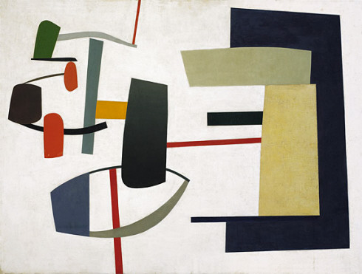

<http://www.guggenheim.org/new-york/collections/collection-online/artwork/1637>

Jean Hélion, *Equilibrium (Equilibre)*, 1933-1934. Oil on canvas, 38 3/8 x 51 5/8 inches (97.4 x 131.2 cm). Solomon R. Guggenheim Foundation, Peggy Guggenheim Collection, Venice 76.2553.44 ©

2014 Artists Rights Society (ARS), New York/ADAGP, Paris.

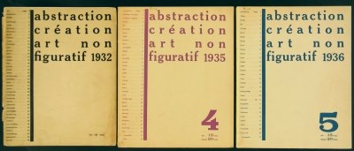

<http://www.stedelijkmuseum.nl/en/artwork/38762-abstraction-creation-art-non-figuratif>

*Abstraction-Création, Art Non-Figuratif*, 1932, 1935, 1936

From Hans (Jean) Arp Collection (Collection of Artists’ Books)

Object number: KBA 944(1-3)

Foundation Stedelijk Museum Amsterdam

Original publication by Edition les tendances nouvelles, Paris

Additional locations:

<http://www.worldcat.org/title/abstraction-creation-art-non-figuratif/oclc/14575328?referer=di&ht=edition>

OCLC number : 637966193

Copies of original journals are also located in following libraries: Metropolitan Museum of Art; Museum of Modern Art (MoMA); National Art Library (NAL); British Library (St. Pancras); University of Cambridge; BNF (Paris)